Missouri “Show-Me” MO-LTAP Scholar Program
A Training and Recognition Program
Introduction
The primary purpose of the MO-LTAP Scholar Program is to recognize skilled transportation and public works personnel in local agencies throughout Missouri. The program is intended to enhance the skills of all those involved in the maintenance, delivery and management of local transportation and infrastructure. Training is aimed at increasing each participant’s technical, maintenance, administrative and supervisory skills depending on the program level. Electives can be selected to meet the individual’s area of responsibility, from the maintenance worker to the supervisor. Special emphasis will be given to safety in the workplace, as well as in the field and in the development of the local transportation system. The program will allow participants to attain three levels of achievements: Level I, Level II and Level III (Supervisory Tract). Participants will be required to meet the requirements for level I before completing Level II; however, Level III will be a stand-alone tract.
Getting Started
To register, complete an application form included in this brochure or available on the Missouri LTAP website (www.moltap.org). There is no registration fee for the program, but there is a fee for each class, which vary for each level. Please see the website for current course fees. Classes are offered on an ongoing basis at various locations throughout the state. Contact MO-LTAP for classes in your area or see the training calendar on the website.
Recognition
Certificates will be awarded by the Missouri LTAP Director to those individuals who successfully complete the requirements of the program during an awards ceremony to be held at various conferences throughout the state, as well as at ceremonies held at the graduate’s place of employment if so desired.

Carhartt Coats Awarded
to Level I Graduates
Carhartt Bibs Awarded
to Level II Graduates
Dress Jackets Awarded
to Level III Graduates
Scholar Level I
Objective: To enhance the skills for all personnel involved in the maintenance of infrastructure. Courses will focus on the basic maintenance of a safe and economical transportation system. Participants will have the opportunity to train in their area of expertise but will be required to also learn the basis of good and sound transportation practices through required courses.
Requirement: To achieve Level I recognition, a participant will be required to successfully complete the three (3) core courses and any five (5) elective courses over a four year period. To maintain an active Level I status, a MO-LTAP Scholar Level I graduate must continue taking Level II courses.
- $40/person for government agencies
- $80/person for private agencies
- All classes are 4 hours (8:00 AM – 12:00 PM)

Core (all 3 required):
- Basic Communication Skills
- Work Zone Safety & Flagger Training
- Worker Safety

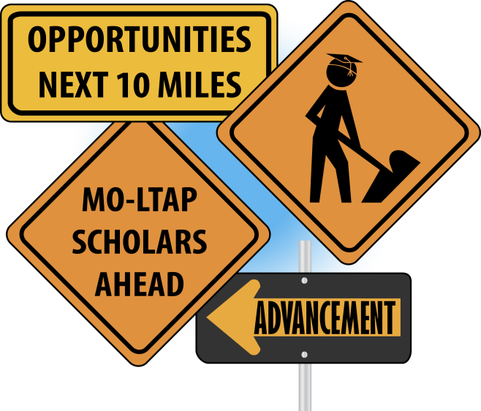

Electives (5 required):
- Basic Construction Math
- Bridge Management & Maintenance
- Chain Saw Safety
- Chip Seal Best Practices
- Culvert Installation and Maintenance
- Defensive Driving
- Equipment Operation & Safety
- Gravel Road Maintenance
- Motor Grader Best Practices
- Snow and Ice Control
- Tractor Mower Safety
- MERC classes:
Hazardous Materials Incident Response*
Chemical Suicide Response*
* One class can be used as an
elective for Level I or Level II
Scholar Level II
Objective: To provide a higher level of training for personnel wanting advanced knowledge of the maintenance of infrastructure. Courses will focus on more in-depth and advanced topics from Level I. Participants can choose courses that most closely relate to their interests to help them excel at their current job or become more qualified for future opportunities in the local transportation or public works industry.
Requirement: To achieve Level II recognition, a participant will be required to successfully complete the Level I requirement first and then complete any eight (8) Level II courses in a four year period.
- $50/person for government agencies, lunch is included
- $100/person for private agencies, lunch is included
- ADA Training & LPA Basics are offered free to local agencies
- Classes are 4 hours unless noted otherwise (10:00 AM – 3:00 PM)
Current Classes (8 required):

- ADA Training
- Bucket Truck Operation & Safety
- Bridge Incident Inspection
- Communicating Effectively
in the Workplace
- Community & Media Relations
- Confined Space Entry
- Construction Documents
- Comprehensive Winter
Planning
- Fall Protection & Personal
Protective Equipment
- Forklift Operation & Safety
- Introduction to Materials:
Concrete, Asphalt & General Materials
- LPA Basics
- Lockout/Tagout
- Pavement Evaluation & Rating
- Sign Retroreflectivity Guidelines Training & Inspection (6 hour class)
- Introduction to Traffic Practices
- Trenching & Shoring
- Work Zone Safety for Law Enforcement
- MERC classes:
Hazardous Materials Incident Response*
Chemical Suicide Response*

Scholar Level III (Supervisory Tract)
Objective: To promote advanced learning for personnel involved in or responsible for the delivery and management of infrastructure projects or other local government initiatives. Courses will focus on topics related to supervisory and management skills. Participants can choose from a variety of courses that will strengthen their interpersonal skills and advance their personal professional development to assist them in their current position or with future career opportunities.
Requirement: To achieve Level III recognition, a participant will be required to complete any eight (8) Level III courses in a four year period. Level III is a stand-alone tract and can be completed without completing Level I or Level II.
- $75/person for government agencies, lunch is included
- $150/person for private agencies, lunch is included
- All classes are 4 hours (10:00 AM – 3:00 PM)
Current Classes (8 required):
- Asset Management & Cost Accounting
- Effective Management for Natural Disasters
- Enhancing Cooperative Work Relationships
- Developing Successful Grant Proposals
- Managing Your Human Resources
- Legal Hotspots of Supervision
- Project Planning and Management
- Supervisory Skills Using Disc Assessment

